[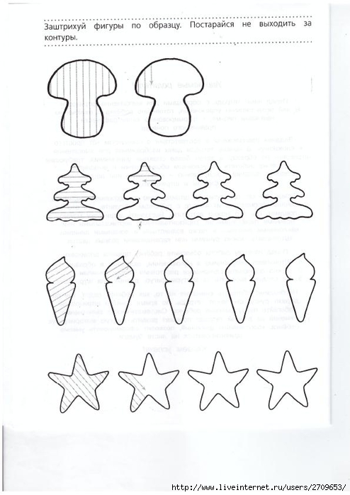](https://img0.liveinternet.ru/images/attach/c/11/117/131/117131744_large_3.jpg)  
  
  
  
  
  
  
  
  
[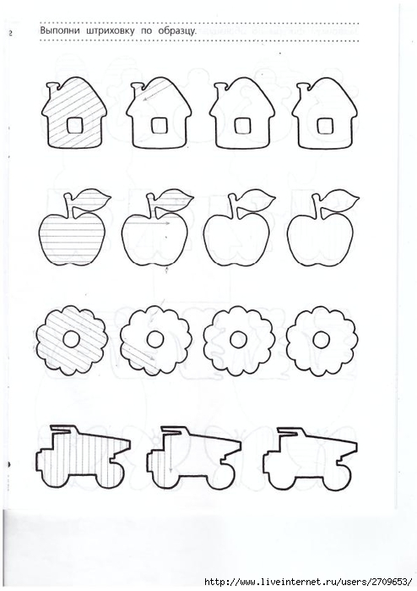](https://img1.liveinternet.ru/images/attach/c/11/117/131/117131747_large_6.jpg)  
  
  
  
  
  
[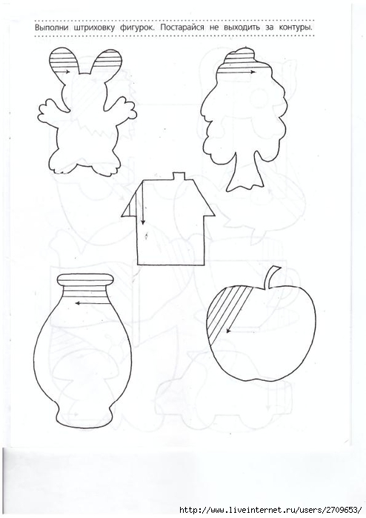](https://img1.liveinternet.ru/images/attach/c/11/117/131/117131749_large_8.jpg)  
  
  
  
  
  
[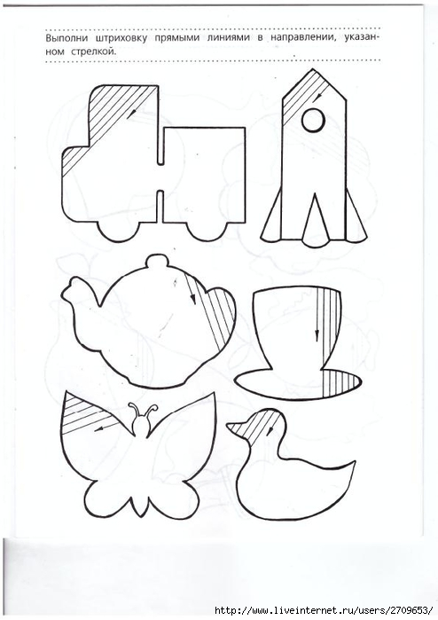](https://img1.liveinternet.ru/images/attach/c/11/117/131/117131751_large_10.jpg)  
  
  
  
  
  
  
  
  
[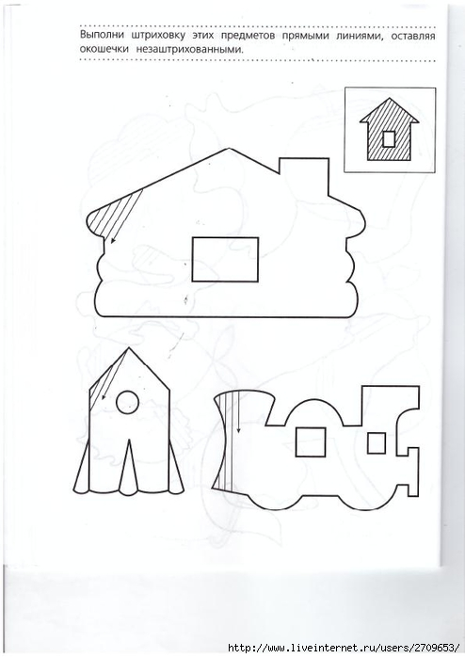](https://img1.liveinternet.ru/images/attach/c/11/117/131/117131755_large_13.jpg)  
  
  
[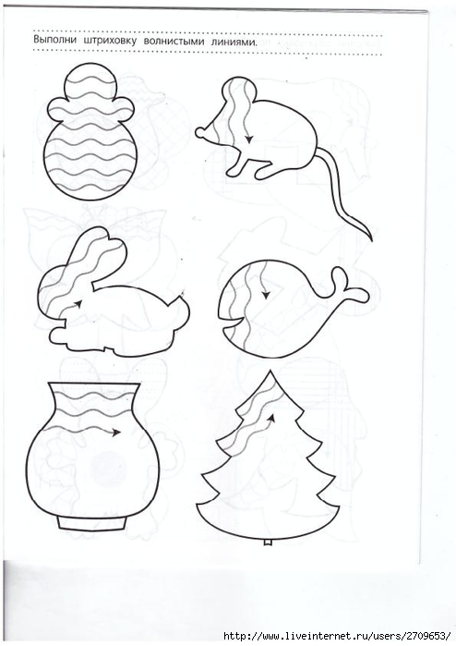](https://img1.liveinternet.ru/images/attach/c/11/117/131/117131757_large_14.jpg)  
  
  
  
  
  
[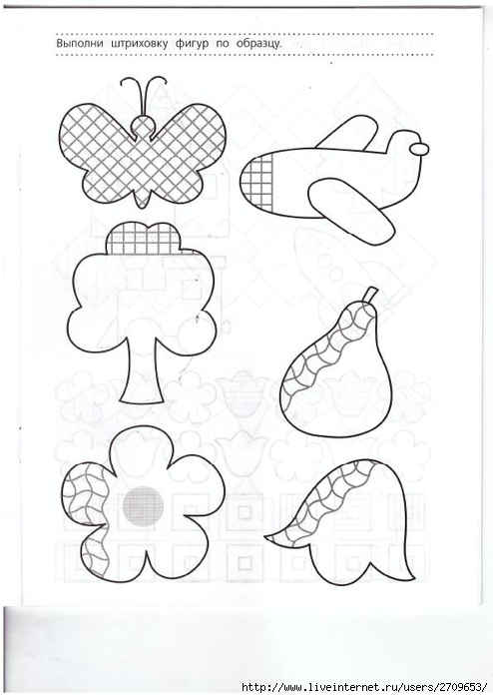](https://img1.liveinternet.ru/images/attach/c/11/117/131/117131759_large_16.jpg)  
  
[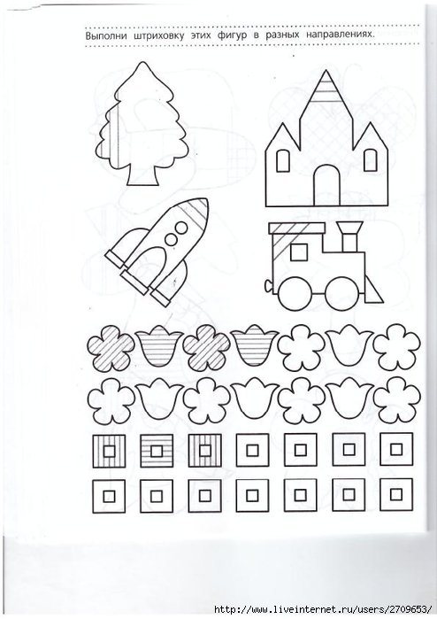](https://img0.liveinternet.ru/images/attach/c/11/117/131/117131760_large_17.jpg)  
  
  
  
  
  
[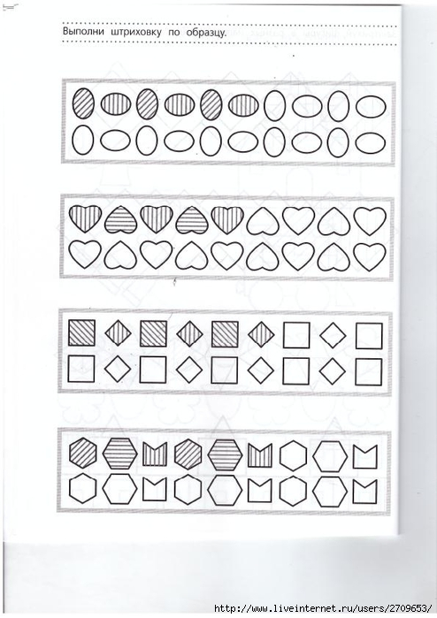](https://img0.liveinternet.ru/images/attach/c/11/117/131/117131762_large_19.jpg)  
  
  
[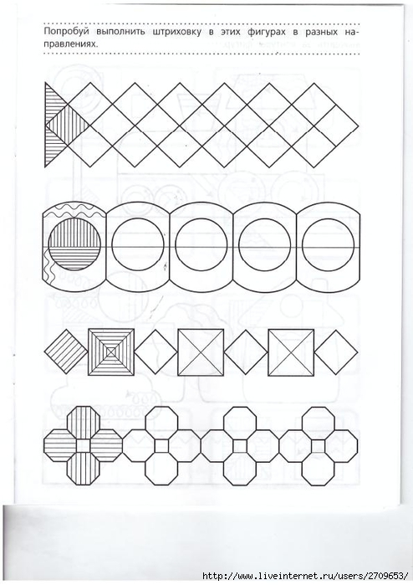](https://img1.liveinternet.ru/images/attach/c/11/117/131/117131763_large_20.jpg)  
  
  
[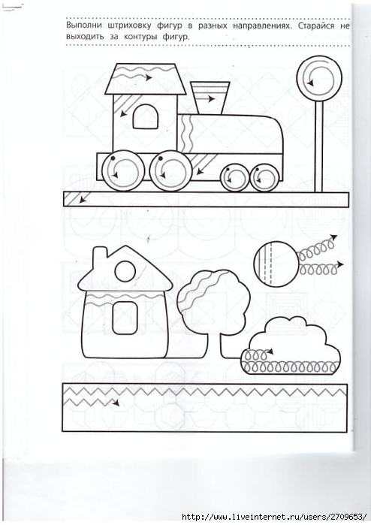](https://img0.liveinternet.ru/images/attach/c/11/117/131/117131764_large_21.jpg)  
  
  
  
  
  
[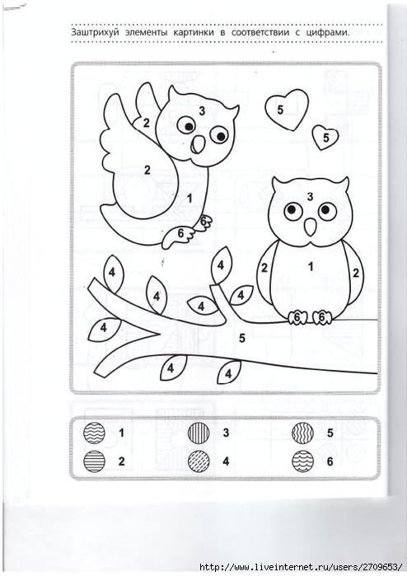](https://img1.liveinternet.ru/images/attach/c/11/117/131/117131767_large_23.jpg)